Vietnamese Rice Paper rolls

This week in the kitchen we prepared Vietnamese Rice Paper Rolls with a dipping sauce and an Asian Salad with chilli & soy dressing. Children were ‘striving for accuracy’ by cutting their vegetables into very thin julienne strips. At the end of the session the children were very excited to receive their knife license.
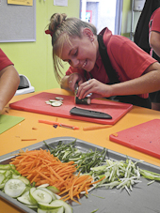
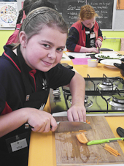

We discussed trying different fillings for the rice paper rolls that the children could try at home. Some suggestions were to add chicken, beef or prawns, as well as adding capsicum strips. The recipe is on the school website so you can give it a try at home.

Thank you to all the wonderful helpers who assisted children learning to cut this week, we really couldn’t have done it without you all.

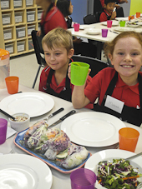
Melanie Nimos
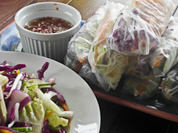
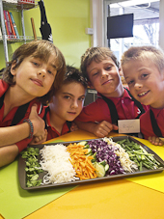
Kitchen Specialist

