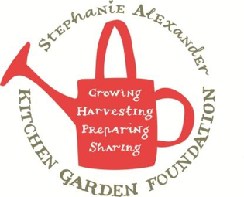

Pak Choy Frittata
Season: All Serves: 2 frittatas (32 tastes)
Difficulty: Easy From the garden: Pak Choy, eggs, spring onions
Allergy advice: contains eggs, dairy (cream), wheat (kecap manis)
Take out a spoonful of stir-fry mix prior to adding eggs and dairy, kids can try vegetables with some gluten free oyster sauce drizzled over.

Equipment:  - Knives  - Chopping Boards  - Large Frying pan  - bowl  - whisk  - measuring jug  - Wooden spatula | Ingredients:  - 1 tablespoon oil  - 2 cloves garlic  - 200g button mushrooms  - 1 bunch pak choy  - 2 cups bean sprouts  - 4 spring onions, thinly sliced  - 10 eggs  - 1 ½ cups cream  - kecap manis to serve

What to do:
- Finely chop garlic
- Lightly brush mushrooms with a clean tea towel, then slice thinly.
- Chop stems and leaves of Pak Choy.
- Slice spring onions on the diagonal.
- Whisk eggs and cream together.
- Heat Griller to 200 degrees
- Heat large frying pan with oil, add garlic and mushrooms, saute for 3-4 minutes or until onions are soft.
- Add pak choy, bean sprouts and spring onions.
- Heat second frying pan with oil and then divide mixture evenly between 2 frying pans.
- Pour over egg and cream mix and cook over a medium/low heat until egg begins to set.
- Finish off cooking of frittata under the griller until golden brown.
- Flip frittata out and drizzle with kecap manis.

