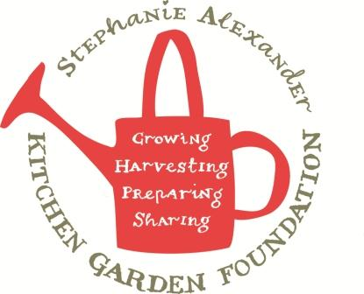

Asparagus and cherry tomato salad

Season: Spring
Type: Accompaniment
Difficulty: Easy
Serves: 32 tastes
From the garden: lettuce

Equipment:  Blender  Salad spinner  Chef’s knife  Chopping board  Juicer  Measuring jug | Ingredients:  6 cups cos lettuce, spinach or other lettuce from garden  1-2 bunches asparagus  1 punnet cherry tomatoes  3 tbs olive oil  1 ½ tbs red wine vinegar  pinch caster sugar  salt  pepper

What to do:
- Collect salad from garden.
- Wash lettuce thoroughly. Dry in the salad spinner. Coarsely shred.
- Wash cherry tomatoes and cut into halves.
- Snap woody ends off asparagus then cut on the diagonal into 4cm pieces.
- Blanch asparagus in boiling water for 3-4 minutes or until bright green and tender crisp. Refresh under cold running water. Drain well.
- Place oil, vinegar, sugar, salt and pepper into a small jar, shake well.
- Divide lettuce, asparagus and tomatoes evenly between 4 salad bowls.
- Drizzle with dressing just before serving.

