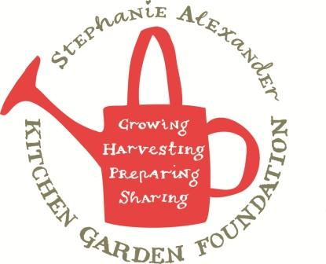

Pumpkin and Chickpea Casserole
Season: summer
Type: main
Difficulty: Medium
Serves: 30-40 tastes
From garden: pumpkin, cherry tomatoes, capsicum, thyme/rosemary

Equipment:  - Chopping board  - Knife  - Frying pan  - Casserole dish  - Foil | Ingredients:  - 1 tbs olive oil  - 1.2kg pumpkin  - 2 red onions  - 1 green or red capsicum  - 2 cans chickpeas  - 2 cloves garlic  - 6 sprigs thyme or rosemary  - 1 ½ cups vegetable stock  - 400g cherry tomatoes  - 200g spinach or silverbeet

What to do:

- Set oven to 190 degrees celcius.
- Cut pumpkin into 1 cm cubes, keep them small so they will cook through in time.
- Cut red onions into wedges and capsicum into thin strips.
- Heat olive oil in frying pan, add pumpkin, red onion and capsicum fry for 10 minutes.
- Meanwhile, drain and rinse chickpeas and make up vegetable stock from stock cube.
- Add garlic and thyme to frying pan, stir to for 1 minute, until aromatic.
- Then add the vegetable stock, tomatoes and chickpeas, mix well.
- Pour into the casserole dish and cover, bake in the oven for 30mins or until pumpkin is soft.
- Wash spinach and clean up.
- Remove casserole from oven, add spinach cover for 2 minutes to allow spinach to wilt then mix well. Serve.

